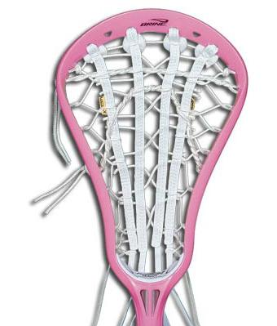
Brine Web-X

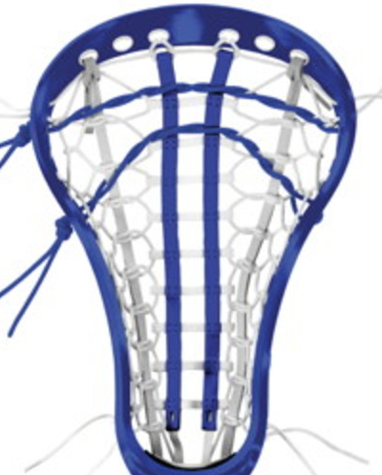
Brine Paramount

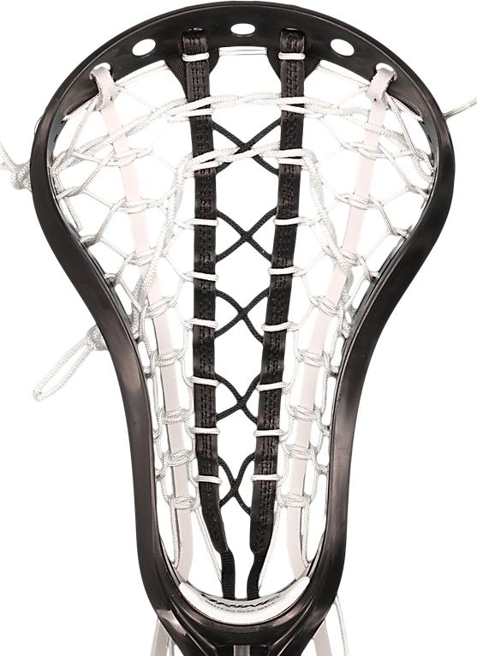
Brine TXP
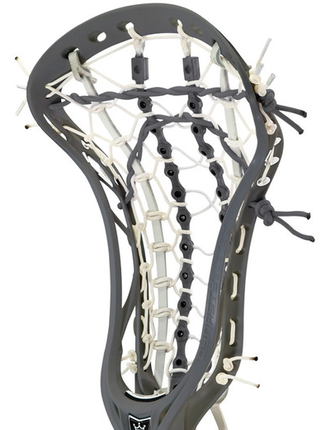
Brine Grid-Flex

Debeer Trakker
** Note, this often needs adjusting on the shooting string as it comes with more than 2 loops. **

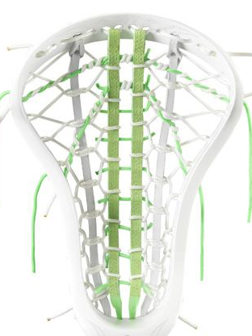
Debeer Trakker Pro
** Note, this often needs adjusting on the shooting string as it comes with more than 2 loops. **

Debeer Gripper
** Note, this often needs adjusting on the shooting string as it comes with more than 2 loops. **

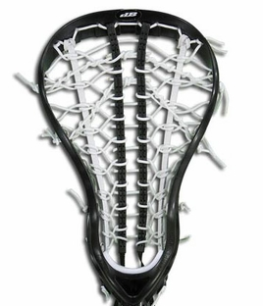
Debeer Gripper Pro
** Note, this often needs adjusting on the shooting string as it comes with more than 2 loops. **

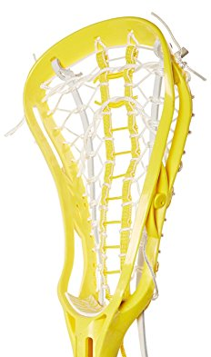
Harrow Snap

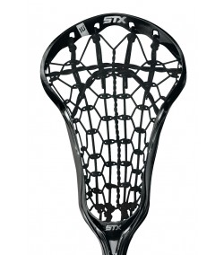
STX Precision

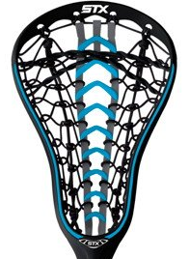
STX Launch
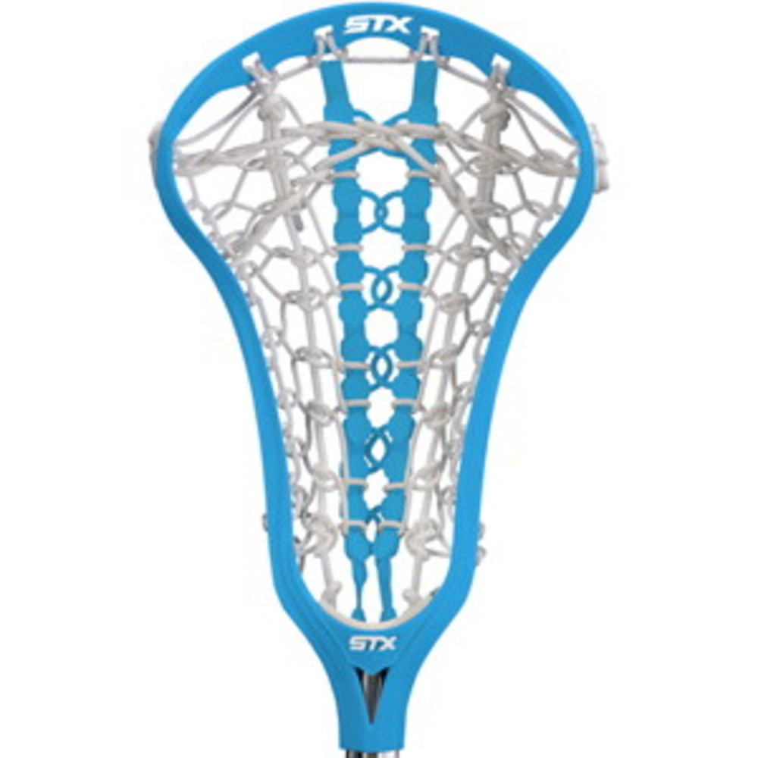
STX Runway

Under Armour Illusion VX

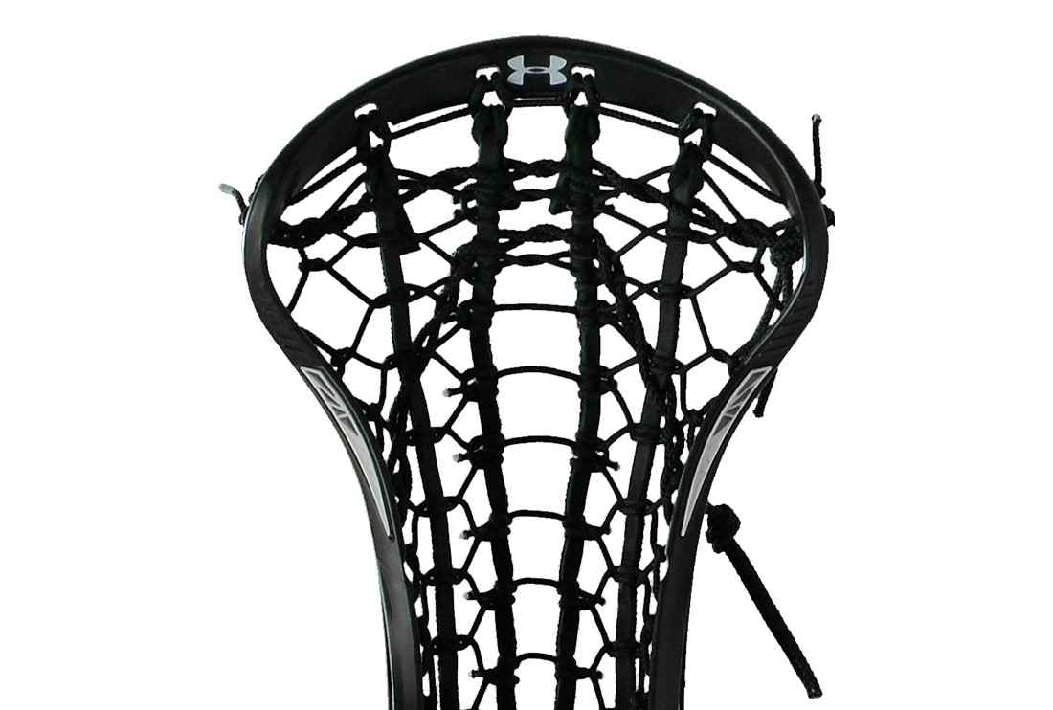
Rail Elite

